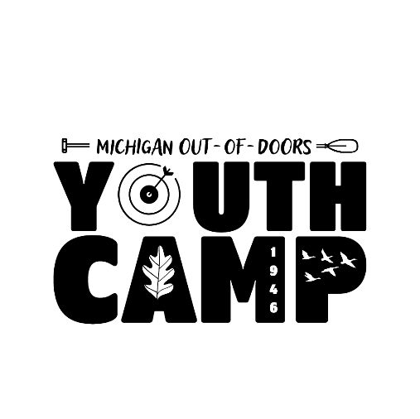 **Club Sponsored Camper - Contact Form**

Please complete this form and email or mail it to the Camp Director BEFORE registration is open to the public on February 10th, 2025. A form needs to be filled out for EACH camper the club is sponsoring. More copies of this form can be found on our website at www.mucccamp.org.

Club Information

Club Name: _____________________________________________________________

Club Contact Person: ______________________________________________________

Email: ______________________________________________________

Phone Number: _______________________________________________

Camper Information

Camper Name: ___________________________________________________________

Camper Birthdate: __________________________________ Male/Female (Circle one)

The week they will be attending camp: ____________________________________________

Parent Name: _____________________________________________________________

Parent Phone Number: ______________________________________________________

Parent Email: ______________________________________________________________

*Payment is not required at time of submitting forms, however, please be aware that **ALL payments are due by MAY 15th, 2025. Additionally, there will be no refunds after this date.**

Mailing Address

ATTN: Youth Camp

2101 Wood Street

Lansing, MI 48912

Camp Director Contact

Shannon Stover

(517) 346 - 6462

[sstover@mucc.org](mailto:sstover@mucc.org)

camp@mucc.org

*MUCC does not contact the parents to inform them their child is being sponsored. That is the club’s responsibility. Once we receive this form, we add them to the registration site on the back end, and they are sent an email from CampDoc to complete the child’s health forms.